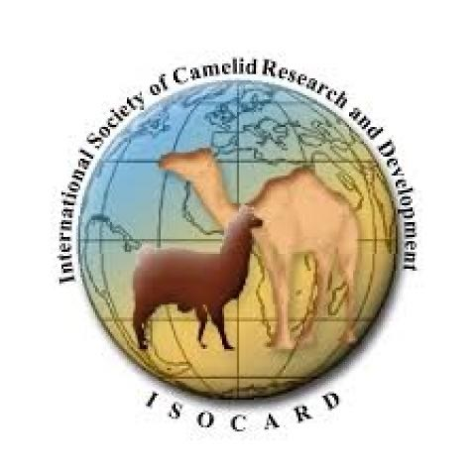

**RECOMMENDATION**

The international community of camel scientists gathered at the 6th ISOCARD (International Society of Camelid Research and Development) conference at AL-Ahsa, Saudi Arabia on 12-16 of March 2023 is expressing its concern regarding the recent decision of the Dutch government and of USDA (United States Department of Agriculture) in USA to exclude camels from the list of domestic animals. This decision came as a big surprise not only to us but also to the wider camel communities around the globe. The decision is non-scientifically based because camels were used by humans for at least 5000 years for riding, milking and other farm activities. Camel products and by products have been scientifically proven to be of much value compared to other domesticated animals. The camel is in strong interaction with humans in so many countries including USA and European countries. The main recommendation of ISOCARD community is to keep the camel as a farm animal with the same status as cattle, equine, small ruminants and others. ISOCARD can support any of the claims mentioned above with scientific literature if needed.